Standard Distributed Schema

The Apache OpenOffice Base module ships with 37 table templates. 15 under the category Personal and 22 as Business.
The 15 Personal table definitions are:
Accounts
Addresses
Authors
Categories
CD-Collection
DietLog
DVD-Collection
ExerciseLog
HouseholdInventory
Investments
Library
MiniatureFilms
Photographs
Plants
Recipes
The 22 Business table definitions are:
Assets
Categories
Contacts
Customers
Deliveries
Employees
EmployeeTasks
Events
Expenses
InvoiceDetails
Invoices
MailingList
OrderDetails
Orders
Payments
Products
Projects
Reservations
Suppliers
Tasks
TimeBilled
Transactions
Using the table wizard full database schemas can be assembled rapidly.
Here are a few such schema.
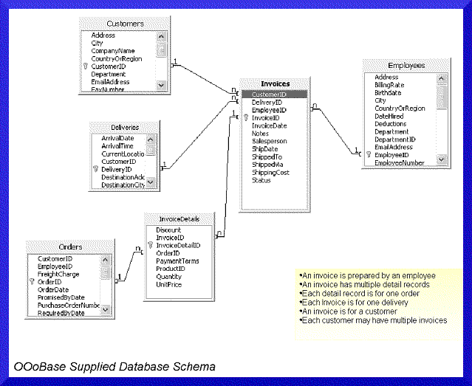
Another look at this without the deliveries table being included.
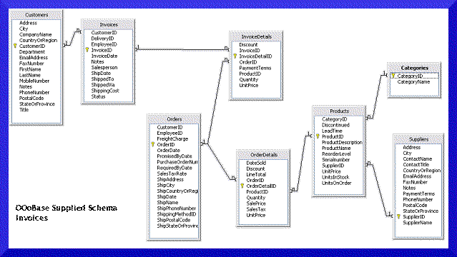
Now a look at the tables for the Order records.
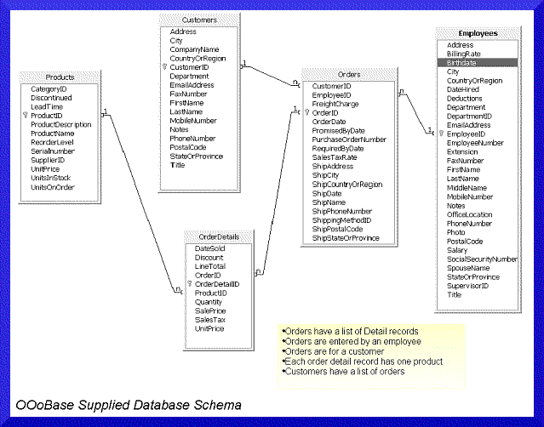
Here is the payments table inlcuded with orders.
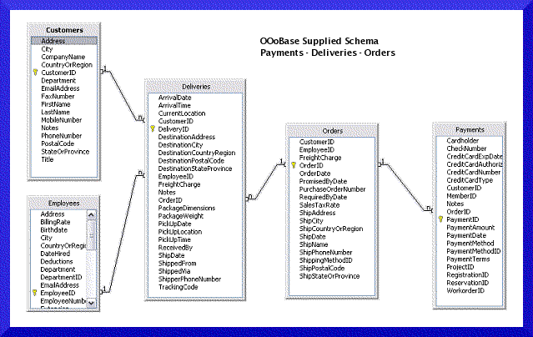
Here is the tables for Tasks and Employees.
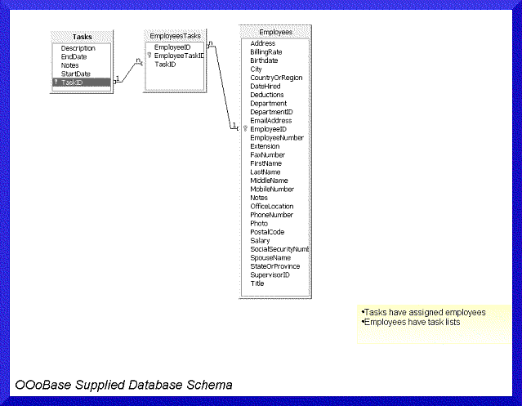
Here is the structure for tracking event reservations.
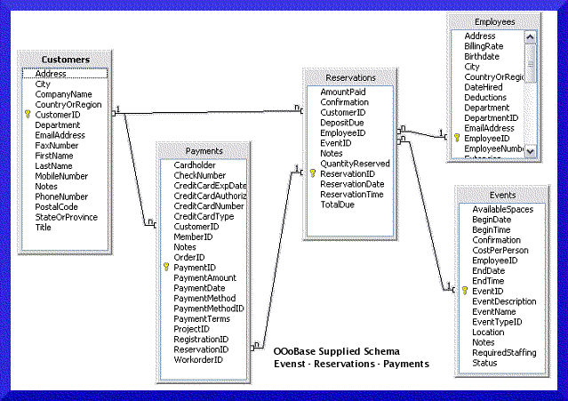
Return to Base Guide/Planning
https://wiki.openoffice.org/wiki/Standard_Distributed_Schema

